APPENDIX A
PHOTOGRAPHS TAKEN DURING JIV 18” TEBIDABA/BRASS PIPELINE AT LAGOSGBENE COMMUNITY, SOUTHERN IJAW L.G.A, BAYELSA STATE ON 7TH JULY, 2024.
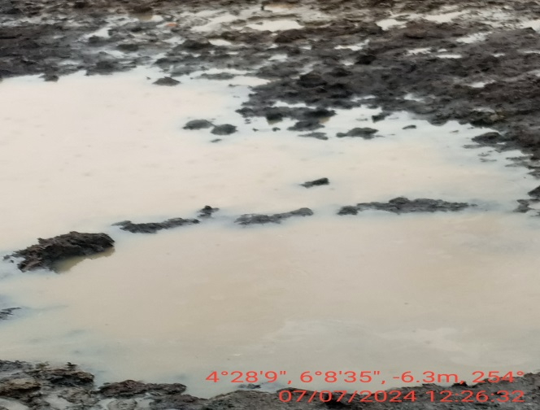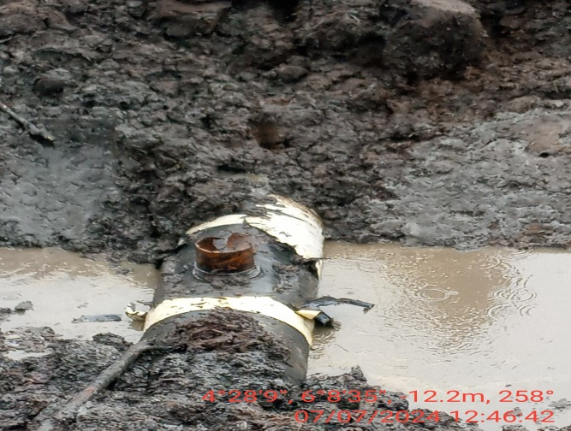
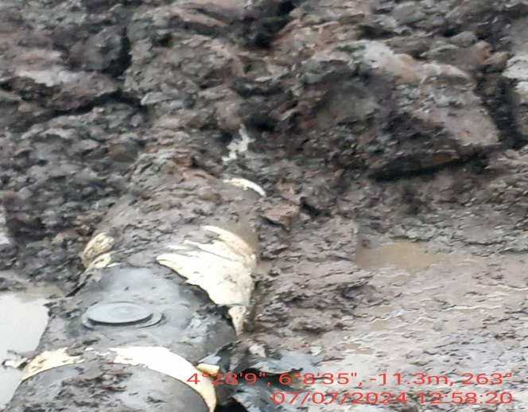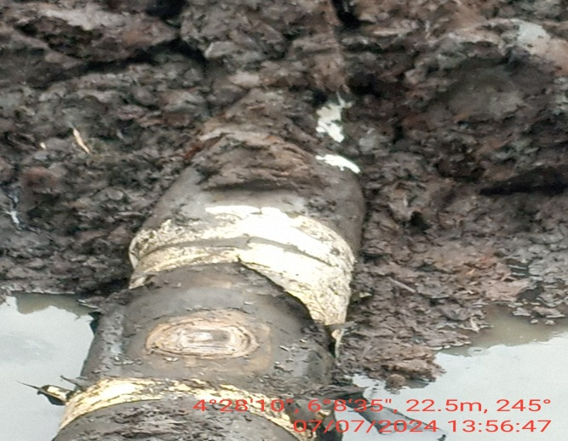
FIG. 1: L-R THE INCIDENT POINT BEFORE EXCAVATION
FIG. 2: THE INCIDENT POINT WITH PLASTIC BUCKET AROUND THE VALVE.
FIG. 3: THE INCIDENT POINT AFTER THE PLASTIC HAS BEEN REMOVED.
FIG. 4: THE INCIDENT POINT AFTER BEING PATCH WELDED.

